Overview of the 10 pages (reduced) of the questionnaire containing 6 prospect pairs each

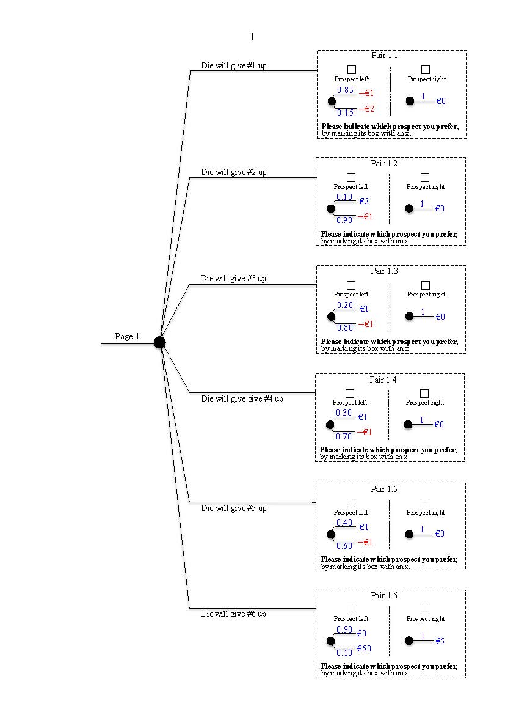

Page 1

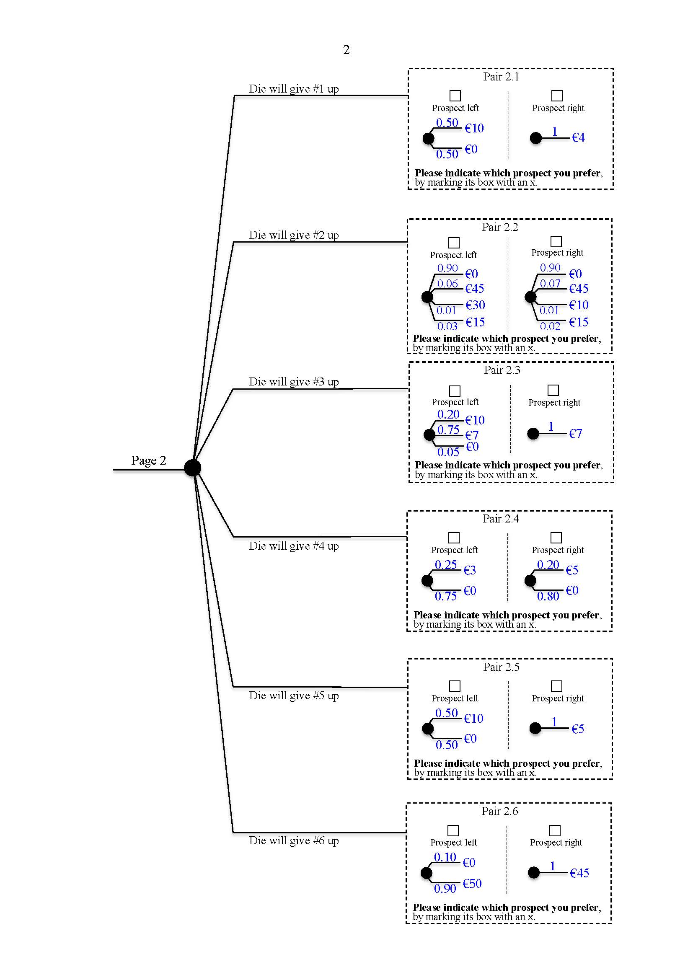

Page 2

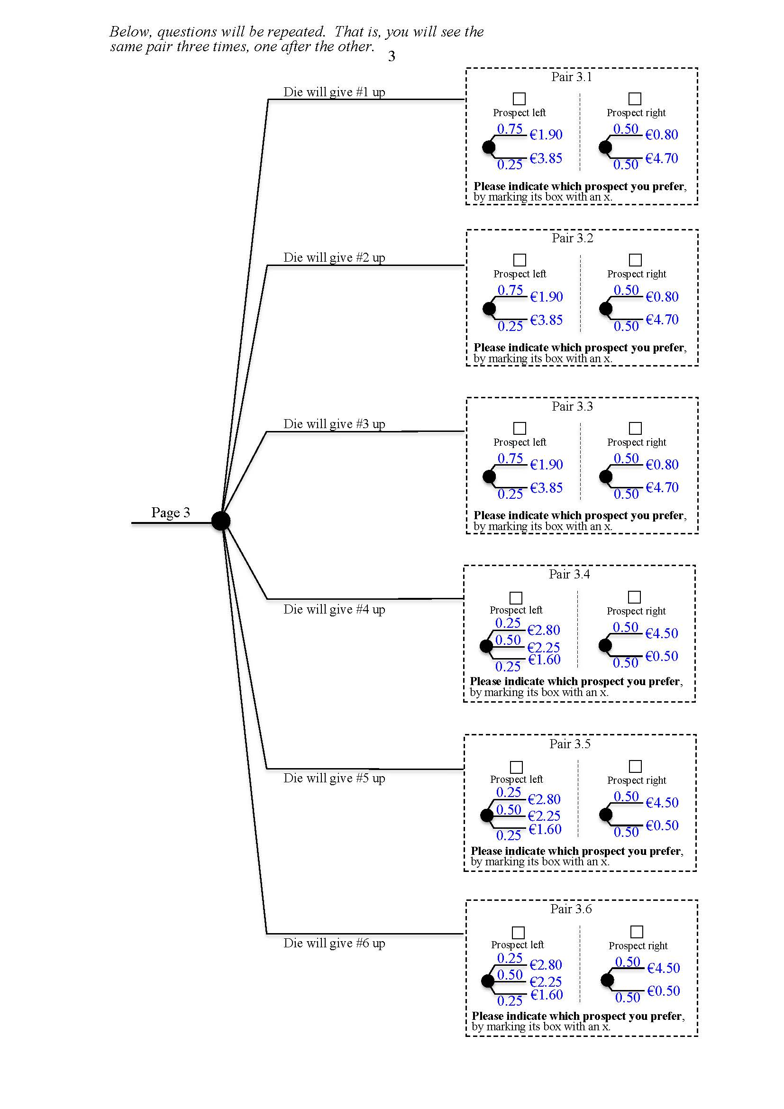

Page 3

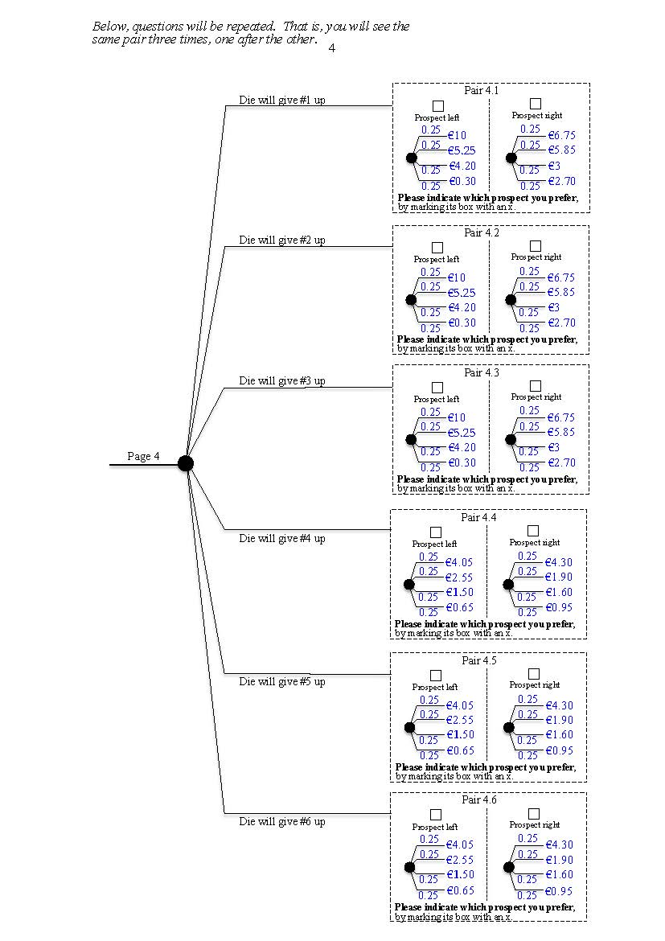

Page 4

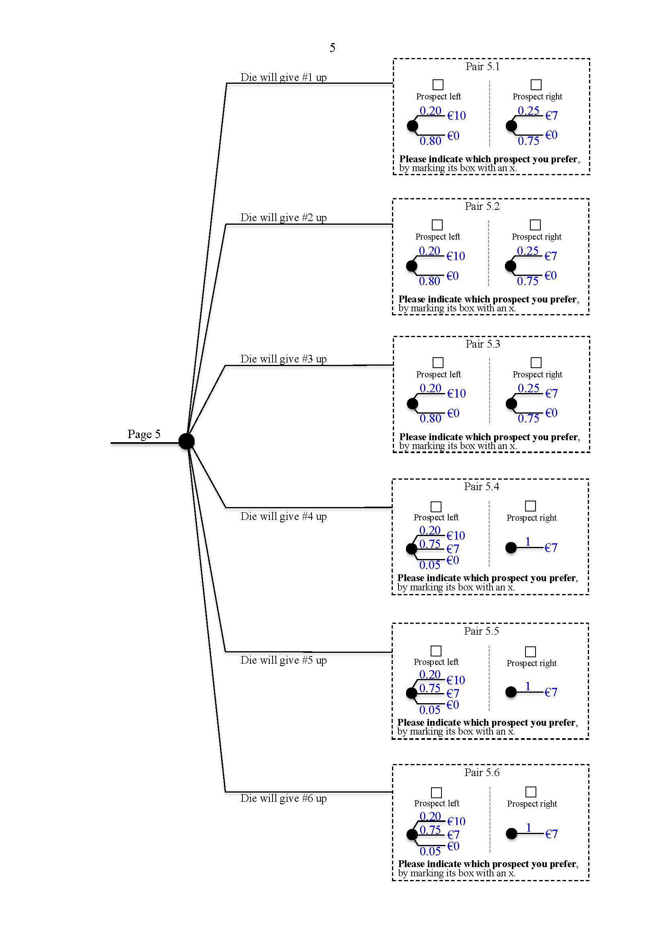

Page 5

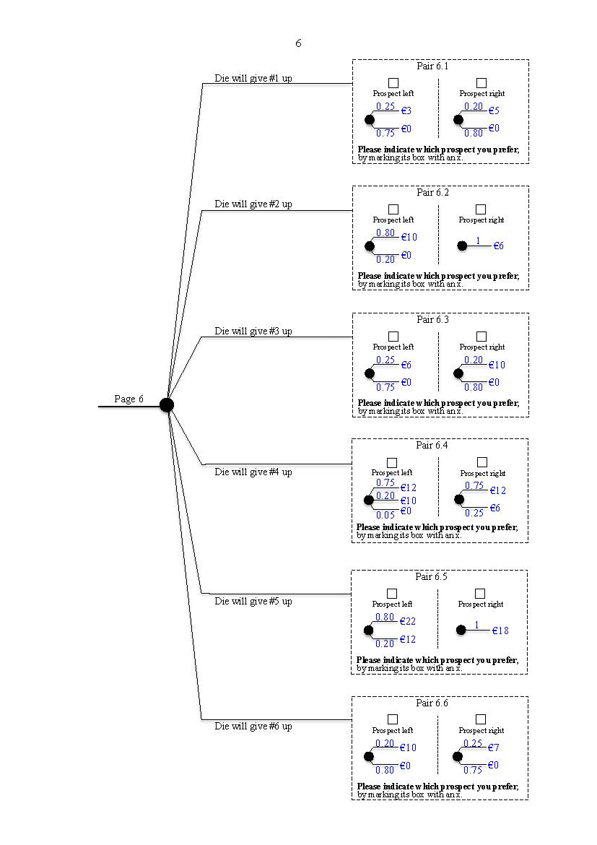

Page 6

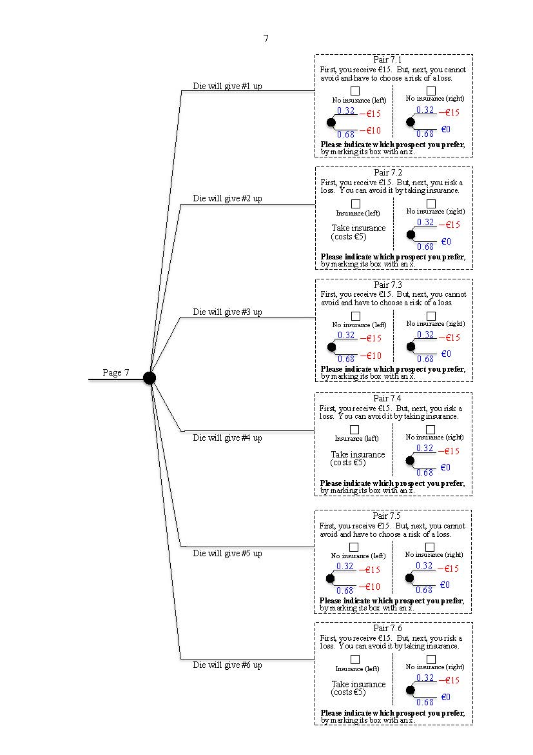

Page 7

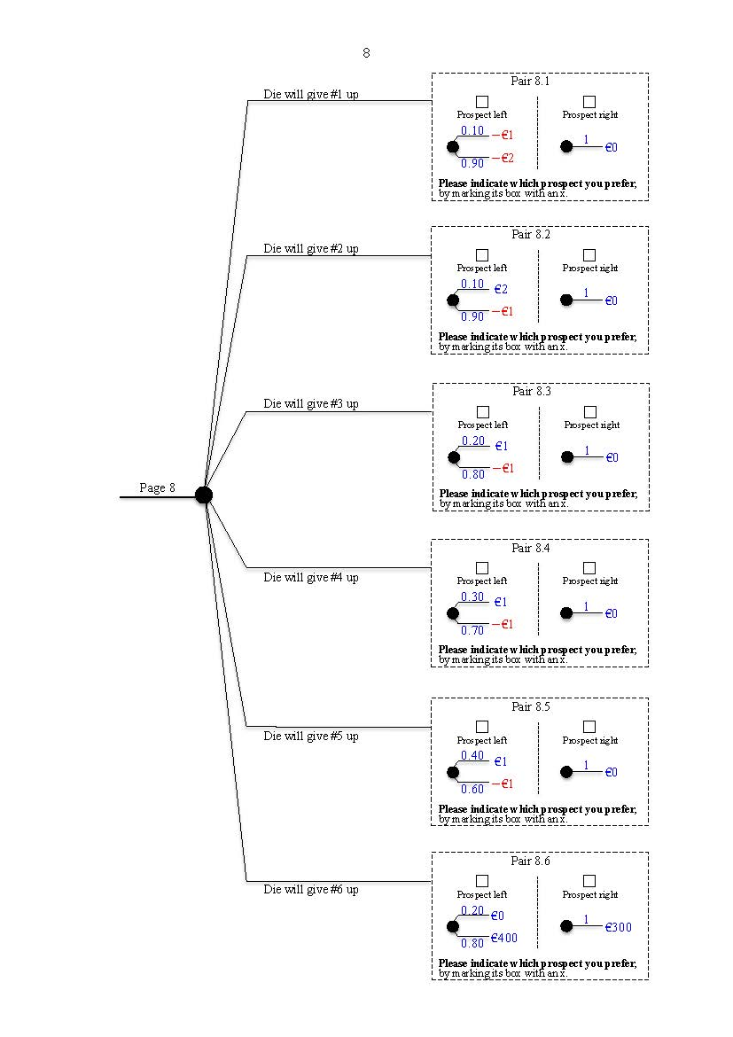

Page 8

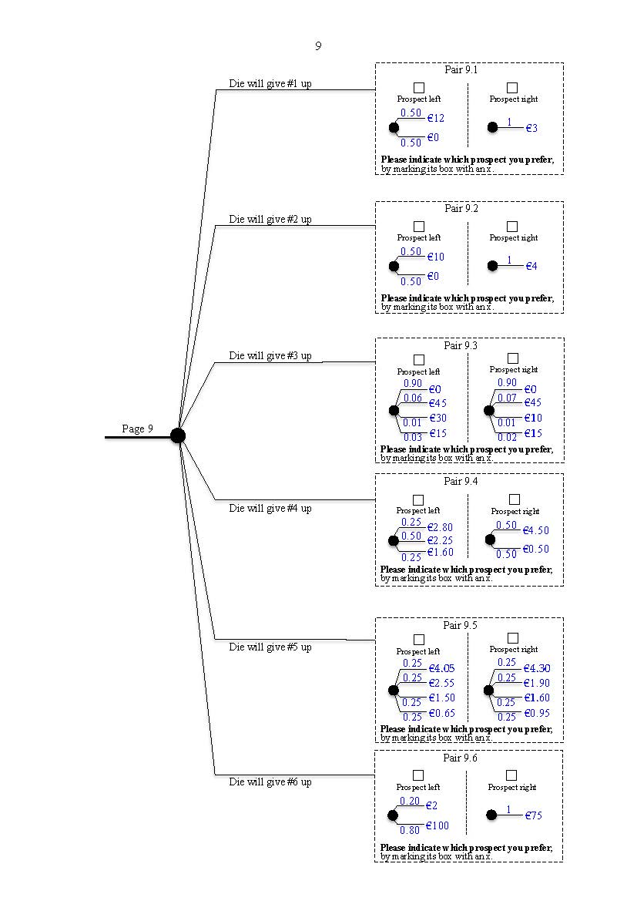

Page 9

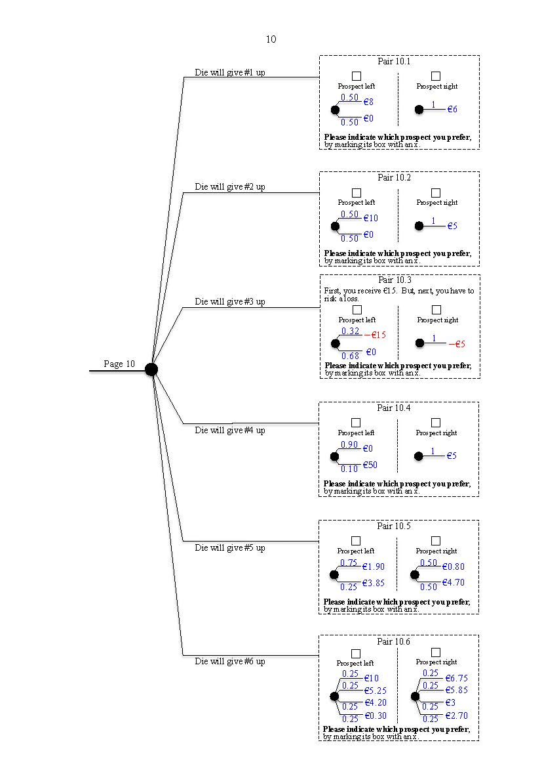

Page 10

The 10 pages follow next, nonreduced.

6-sided die will give #1 up

Pair 1.1

Prospect right

Prospect left

0.85

€0

1

$-$ €1

$-$ €2

0.15

**Please indicate which prospect you prefer**, by marking its box with an x.

6-sided die will give #2 up

Pair 1.2

Prospect right

Prospect left

0.10

1

€0

€2

$-$ €1

0.90

**Please indicate which prospect you prefer**, by marking its box with an x.

6-sided die will give #3 up

Pair 1.3

Prospect right

Prospect left

1

€0

0.20

€1

$-$ €1

0.80

Page 1

**Please indicate which prospect you prefer**, by marking its box with an x.

Pair 1.4

Prospect right

Prospect left

6-sided die will give give #4 up

€0

0.30

1

€1

$-$ €1

0.70

**Please indicate which prospect you prefer**, by marking its box with an x.

Pair 1.5

6-sided die will give #5 up

Prospect right

Prospect left

1

0.40

€1

€0

$-$ €1

0.60

**Please indicate which prospect you prefer**, by marking its box with an x.

Pair 1.6

6-sided die will give #6 up

Prospect right

Prospect left

1

0.90

€0

0.10

€5

€50

**Please indicate which prospect you prefer**, by marking its box with an x.

6-sided die will give #1 up

Pair 2.1

Prospect right

Prospect left

0.50

€4

1

€10

€0

0.50

**Please indicate which prospect you prefer**, by marking its box with an x.

6-sided die will give #2 up

Pair 2.2

Prospect right

Prospect left

0.90

0.90

€45

€0

€45

€0

0.07

0.06

€10

€30

0.01

0.01

**Please indicate which prospect you prefer**, by marking its box with an x.

€15

€15

0.02

0.03

6-sided die will give #3 up

Prospect right

Pair 2.3

Prospect left

€7

0.20

1

€7

€10

0.75

€0

0.05

Page 2

**Please indicate which prospect you prefer**, by marking its box with an x.

Pair 2.4

Prospect right

Prospect left

6-sided die will give #4 up

€5

0.20

€3

0.25

€0

€0

0.80

0.75

**Please indicate which prospect you prefer**, by marking its box with an x.

Pair 2.5

6-sided die will give #5 up

Prospect left

€0

Prospect right

1

€5

0.50

€10

0.50

**Please indicate which prospect you prefer**, by marking its box with an x.

Pair 2.6

Prospect right

Prospect left

6-sided die will give #6 up

1

€45

0.10

€0

€50

0.90

**Please indicate which prospect you prefer**, by marking its box with an x.

Pair 3.1

Prospect right

Prospect left

*Below, questions will be repeated. That is, you will see the same pair three times, one after the other.*

6-sided die will give #1 up

€0.80

0.50

€1.90

0.75

€4.70

€3.85

0.50

0.25

**Please indicate which prospect you prefer**, by marking its box with an x.

Pair 3.2

Prospect right

Prospect left

6-sided die will give #2 up

€0.80

0.50

€1.90

0.75

€4.70

€3.85

0.50

0.25

**Please indicate which prospect you prefer**, by marking its box with an x.

Pair 3.3

Prospect right

Prospect left

6-sided die will give #3 up

€0.80

0.50

€1.90

0.75

€4.70

€3.85

0.50

0.25

**Please indicate which prospect you prefer**, by marking its box with an x.

Page 3

Pair 3.4

€4.50

€0.50

Prospect right

0.50

0.50

6-sided die will give #4 up

0.25

Prospect left

€2.80

€2.25

0.50

€1.60

**Please indicate which prospect you prefer**, by marking its box with an x.

0.25

Pair 3.5

€4.50

€0.50

Prospect right

0.50

0.50

6-sided die will give #5 up

0.25

Prospect left

0.50

€2.80

€2.25

0.25

€1.60

**Please indicate which prospect you prefer**, by marking its box with an x.

€4.50

€0.50

Prospect right

0.50

0.50

Pair 3.6

0.25

Prospect left

6-sided die will give #6 up

0.50

€2.80

€2.25

0.25

€1.60

**Please indicate which prospect you prefer**, by marking its box with an x.

*Below, questions will be repeated. That is, you will see the same pair three times, one after the other.*

Pair 4.1

6-sided die will give #1 up

Prospect right

Prospect left

€6.75

€10

0.25

0.25

€5.85

€4.20

€3

€5.25

0.25

0.25

€0.30

€2.70

0.25

0.25

0.25

0.25

0.25

0.25

0.25

0.25

**Please indicate which prospect you prefer**, by marking its box with an x.

Pair 4.2

6-sided die will give #2 up

Prospect right

Prospect left

€6.75

€10

0.25

0.25

€5.85

€5.25

0.25

0.25

€0.30

€0.30

€2.70

€4.20

€3

€4.20

€3

**Please indicate which prospect you prefer**, by marking its box with an x.

**Please indicate which prospect you prefer**, by marking its box with an x.

0.25

0.25

Pair 4.3

6-sided die will give #3 up

Prospect right

Prospect left

€6.75

€10

0.25

0.25

€5.85

€5.25

0.25

0.25

€2.70

Page 4

0.25

0.25

Pair 4.4

Prospect right

Prospect left

6-sided die will give #4 up

0.25

0.25

€1.90

€1.90

€1.90

€4.30

€4.05

€2.55

0.25

0.25

€0.65

€0.65

€0.65

€0.95

€1.50

€1.50

€1.50

€1.60

0.25

0.25

0.25

0.25

0.25

0.25

**Please indicate which prospect you prefer**, by marking its box with an x.

0.25

0.25

Pair 4.5

Prospect right

Prospect left

6-sided die will give #5 up

€4.30

€4.05

€2.55

0.25

0.25

0.25

0.25

€1.60

€0.95

0.25

0.25

**Please indicate which prospect you prefer**, by marking its box with an x.

Pair 4.6

Prospect right

Prospect left

6-sided die will give #6 up

€4.30

€4.05

€2.55

0.25

0.25

0.25

0.25

€0.95

0.25

0.25

**Please indicate which prospect you prefer**, by marking its box with an x.

€1.60

Pair 5.1

Prospect right

Prospect left

6-sided die will give #1 up

€7

0.25

€10

0.20

€0

€0

0.75

0.80

**Please indicate which prospect you prefer**, by marking its box with an x.

Pair 5.2

Prospect right

Prospect left

6-sided die will give #2 up

€7

0.25

€10

0.20

€0

€0

0.75

0.80

**Please indicate which prospect you prefer**, by marking its box with an x.

Pair 5.3

Prospect right

Prospect left

6-sided die will give #3 up

€7

0.25

€10

0.20

€0

€0

0.75

0.80

**Please indicate which prospect you prefer**, by marking its box with an x.

Page 5

Pair 5.4

Prospect right

6-sided die will give #4 up

€10

0.20

Prospect left

€0

€7

0.75

1

€7

**Please indicate which prospect you prefer**, by marking its box with an x.

0.05

Prospect right

Pair 5.5

6-sided die will give #5 up

0.20

Prospect left

€7

€10

0.75

1

€7

0.05

€0

**Please indicate which prospect you prefer**, by marking its box with an x.

Prospect right

Pair 5.6

6-sided die will give #6 up

Prospect left

0.75

€7

€10

0.20

1

€7

€0

0.05

**Please indicate which prospect you prefer**, by marking its box with an x.

Pair 6.1

Prospect right

Prospect left

6-sided die will give #1 up

0.20

0.25

€5

€0

€3

€0

0.80

0.75

**Please indicate which prospect you prefer**, by marking its box with an x.

Pair 6.2

Prospect right

Prospect left

6-sided die will give #2 up

0.80

€6

1

€10

€0

0.20

**Please indicate which prospect you prefer**, by marking its box with an x.

Pair 6.3

Prospect right

Prospect left

6-sided die will give #3 up

€10

0.20

€6

0.25

€0

€0

0.80

0.75

Page 6

**Please indicate which prospect you prefer**, by marking its box with an x.

Prospect right

Pair 6.4

0.75

6-sided die will give #4 up

Prospect left

0.20

0.75

€12

€12

€10

0.05

€6

0.25

€0

**Please indicate which prospect you prefer**, by marking its box with an x.

Pair 6.5

6-sided die will give #5 up

Prospect right

Prospect left

1

0.80

€22

€18

€12

0.20

**Please indicate which prospect you prefer**, by marking its box with an x.

Pair 6.6

Prospect right

Prospect left

6-sided die will give #6 up

€7

0.25

€10

0.20

€0

€0

0.75

0.80

**Please indicate which prospect you prefer**, by marking its box with an x.

Pair 7.1

First, you receive €15. But, next, you cannot avoid and have to choose a risk of a loss.

6-sided die will give #1 up

No insurance (left)

No insurance (right)

0.32

$-$ €15

$-$ €15

0.32

$-$ €15

$-$ €10

0.68

€0

**Please indicate which prospect you prefer**, by marking its box with an x.

**Please indicate which prospect you prefer**, by marking its box with an x.

**Please indicate which prospect you prefer**, by marking its box with an x.

0.68

Pair 7.2

First, you receive €15. But, next, you risk a loss. You can avoid it by taking insurance.

6-sided die will give #2 up

No insurance (right)

Insurance (left)

0.32

Take insurance (costs €5)

€0

0.68

Pair 7.3

First, you receive €15. But, next, you cannot avoid and have to choose a risk of a loss.

6-sided die will give #3 up

No insurance (left)

No insurance (right)

$-$ €15

0.32

0.32

$-$ €15

$-$ €10

0.68

€0

0.68

Page 7

Pair 7.4

First, you receive €15. But, next, you risk a loss. You can avoid it by taking insurance.

No insurance (right)

Insurance (left)

6-sided die will give #4 up

0.32

Take insurance (costs €5)

$-$ €15

$-$ €15

€0

**Please indicate which prospect you prefer**, by marking its box with an x.

0.68

Pair 7.5

First, you receive €15. But, next, you cannot avoid and have to choose a risk of a loss.

6-sided die will give #5 up

No insurance (left)

No insurance (right)

$-$ €15

0.32

0.32

$-$ €15

$-$ €10

0.68

0.68

€0

**Please indicate which prospect you prefer**, by marking its box with an x.

Pair 7.6

First, you receive €15. But, next, you risk a loss. You can avoid it by taking insurance.

Insurance (left)

6-sided die will give #6 up

No insurance (right)

Take insurance (costs €5)

0.32

**Please indicate which prospect you prefer**, by marking its box with an x.

0.68

€0

Pair 8.1

Prospect right

Prospect left

6-sided die will give #1 up

0.10

$-$ €1

1

€0

$-$ €2

0.90

**Please indicate which prospect you prefer**, by marking its box with an x.

Pair 8.2

Prospect right

Prospect left

6-sided die will give #2 up

0.10

1

€0

€2

$-$ €1

0.90

**Please indicate which prospect you prefer**, by marking its box with an x.

Pair 8.3

Prospect right

Prospect left

6-sided die will give #3 up

1

€0

0.20

€1

$-$ €1

0.80

Page 8

**Please indicate which prospect you prefer**, by marking its box with an x.

Pair 8.4

Prospect right

Prospect left

6-sided die will give #4 up

1

€0

0.30

€1

$-$ €1

0.70

**Please indicate which prospect you prefer**, by marking its box with an x.

Pair 8.5

Prospect right

Prospect left

6-sided die will give #5 up

1

€0

0.40

€1

$-$ €1

0.60

**Please indicate which prospect you prefer**, by marking its box with an x.

Pair 8.6

Prospect right

Prospect left

6-sided die will give #6 up

1

0.20

€0

€300

€400

0.80

**Please indicate which prospect you prefer**, by marking its box with an x.

6-sided die will give #1 up

Prospect right

Pair 9.1

Prospect left

0.50

€12

1

€3

€0

0.50

**Please indicate which prospect you prefer**, by marking its box with an x.

6-sided die will give #2 up

Pair 9.2

Prospect right

Prospect left

1

€4

0.50

€10

0.50

€0

**Please indicate which prospect you prefer**, by marking its box with an x.

6-sided die will give #3 up

Pair 9.3

Prospect right

Prospect left

0.90

0.90

€45

€0

€0

€45

0.07

0.06

0.01

0.01

€30

€10

Page 9

**Please indicate which prospect you prefer**, by marking its box with an x.

€15

€15

0.02

0.03

€4.50

€0.50

Prospect right

0.50

0.50

Pair 9.4

6-sided die will give #4 up

Prospect left

0.50

0.25

€2.80

€2.25

Pair 7.5

€15

0.01

€0

0.03

€45

0.06

€30

0.90

O#ion right

O#ion left

€15

0.01

€0

0.02

€45

0.07

€10

0.90

**Please give us instructions** on which o#on to give to you, by marking its box with an x.

0.25

€1.60

**Please indicate which prospect you prefer**, by marking its box with an x.

Pair 9.5

6-sided die will give #5 up

Prospect right

Prospect left

€4.30

€4.05

0.25

0.25

€1.90

€1.50

€1.60

€2.55

0.25

0.25

€0.65

€0.95

0.25

0.25

0.25

0.25

**Please indicate which prospect you prefer**, by marking its box with an x.

Pair 9.6

6-sided die will give #6 up

Prospect right

Prospect left

1

0.20

€2

€75

€100

0.80

**Please indicate which prospect you prefer**, by marking its box with an x.

6-sided die will give #1 up

Pair 10.1

Prospect right

Prospect left

0.50

€6

1

€8

€0

0.50

**Please indicate which prospect you prefer**, by marking its box with an x.

6-sided die will give #2 up

Pair 10.2

Prospect right

Prospect left

€5

1

0.50

€10

€0

0.50

**Please indicate which prospect you prefer**, by marking its box with an x.

Pair 10.3

6-sided die will give #3 up

First, you receive €15. But, next, you have to risk a loss.

Prospect right

Prospect left

1

$-$ €5

0.32

$-$ €15

0.68

€0

**Please indicate which prospect you prefer**, by marking its box with an x.

Page 10

Pair 10.4

6-sided die will give #4 up

Prospect right

Prospect left

€5

1

0.90

€0

€50

0.10

**Please indicate which prospect you prefer**, by marking its box with an x.

Pair 10.5

Prospect right

Prospect left

6-sided die will give #5 up

0.50

€0.80

€1.90

0.75

0.50

€4.70

€3.85

0.25

**Please indicate which prospect you prefer**, by marking its box with an x.

Pair 10.6

6-sided die will give #6 up

Prospect right

Prospect left

€6.75

€4.20

€3

€10

0.25

0.25

€5.85

€5.25

0.25

0.25

**Please indicate which prospect you prefer**, by marking its box with an x.

€0.30

€2.70

0.25

0.25

0.25

0.25