Overview of the 10 pages (reduced) of the questionnaire containing 6 prospect pairs each

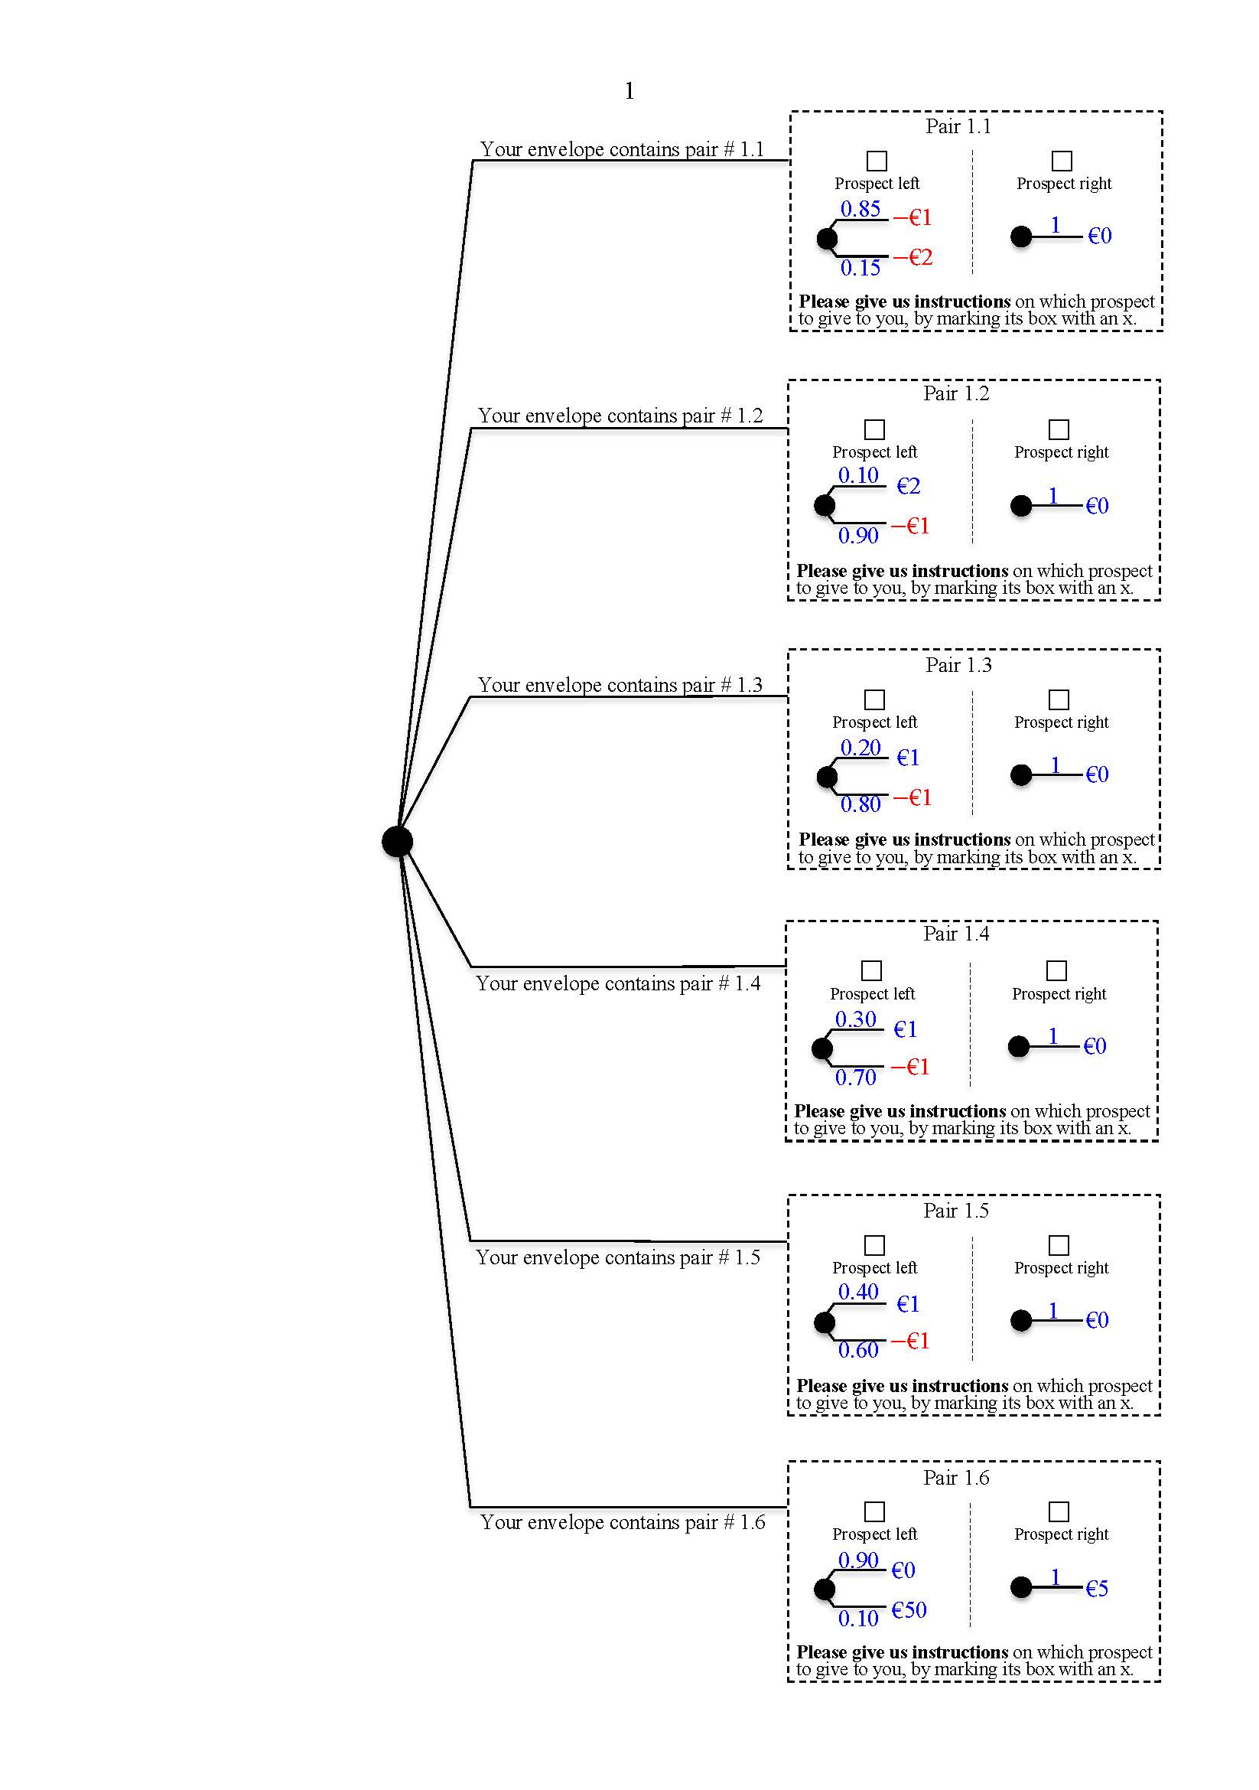

Page 1

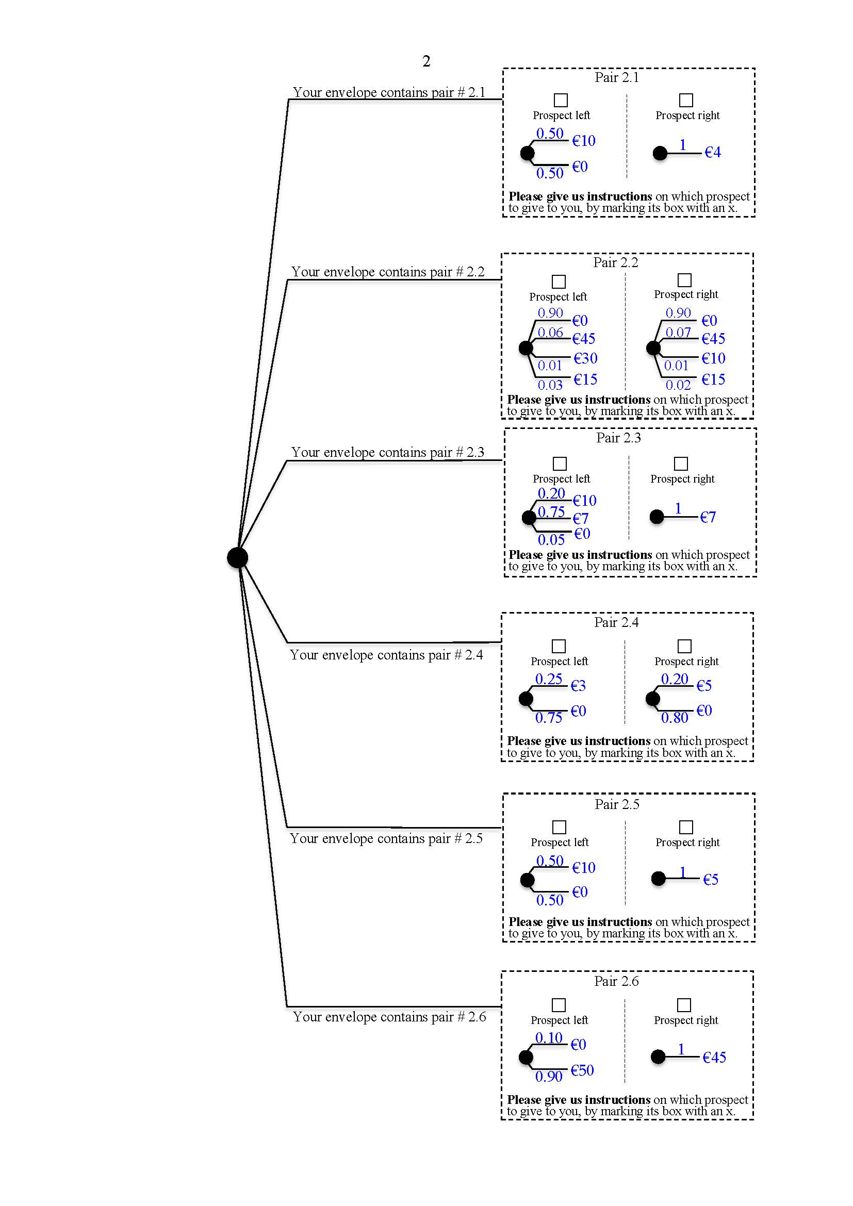

Page 2

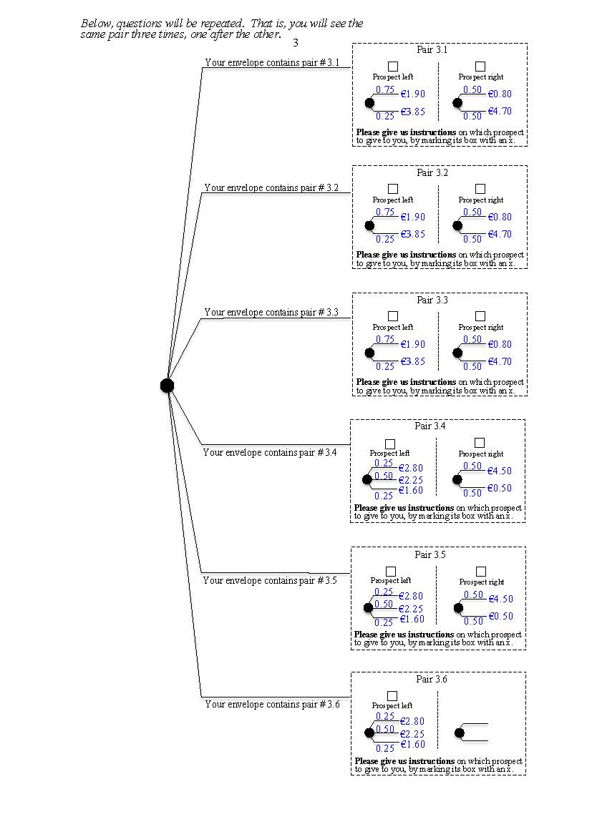

Page 3

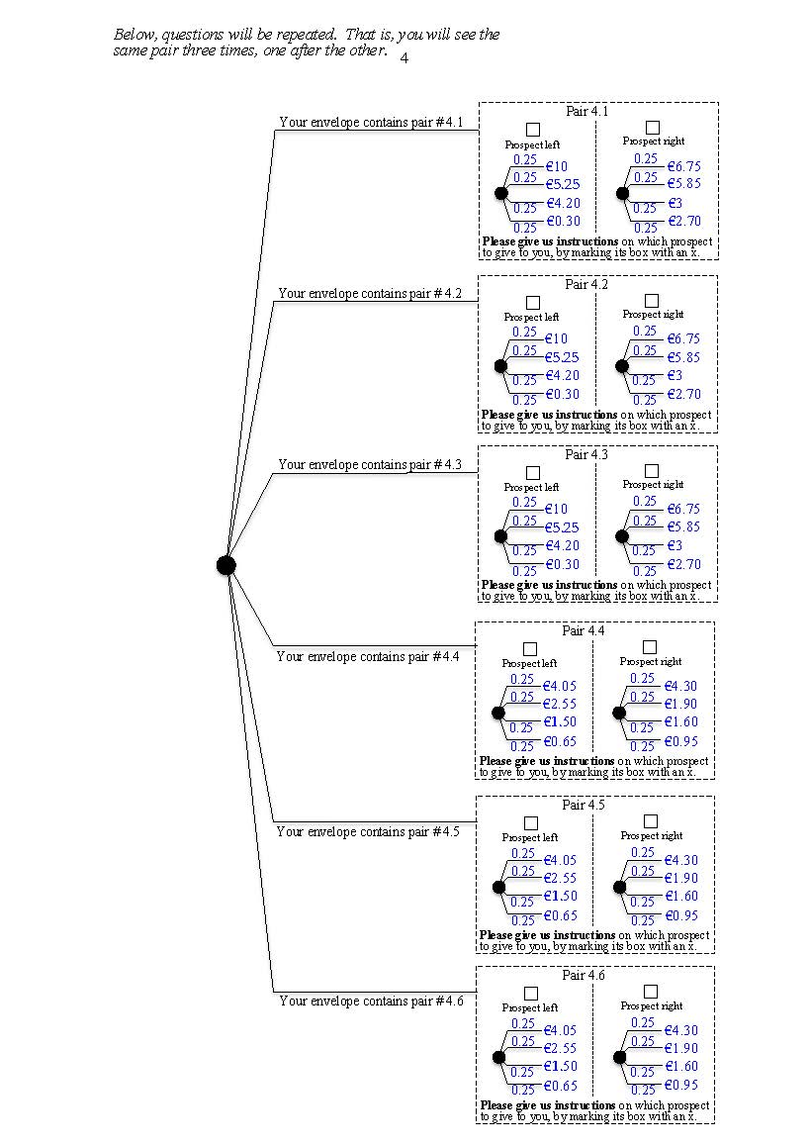

Page 4

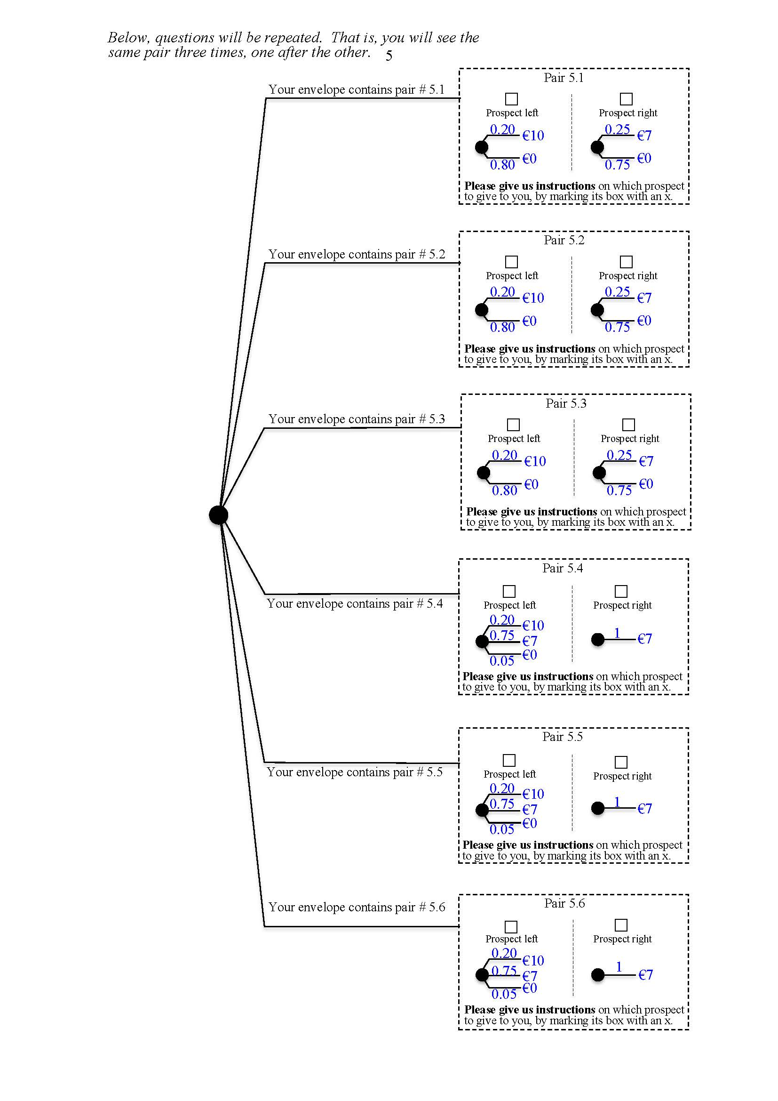

Page 5

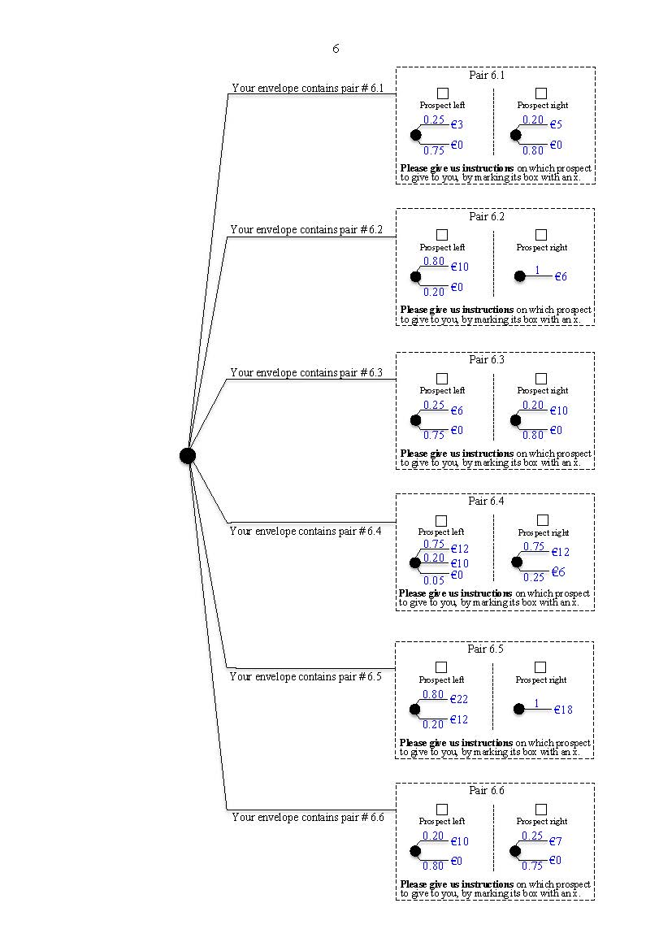

Page 6

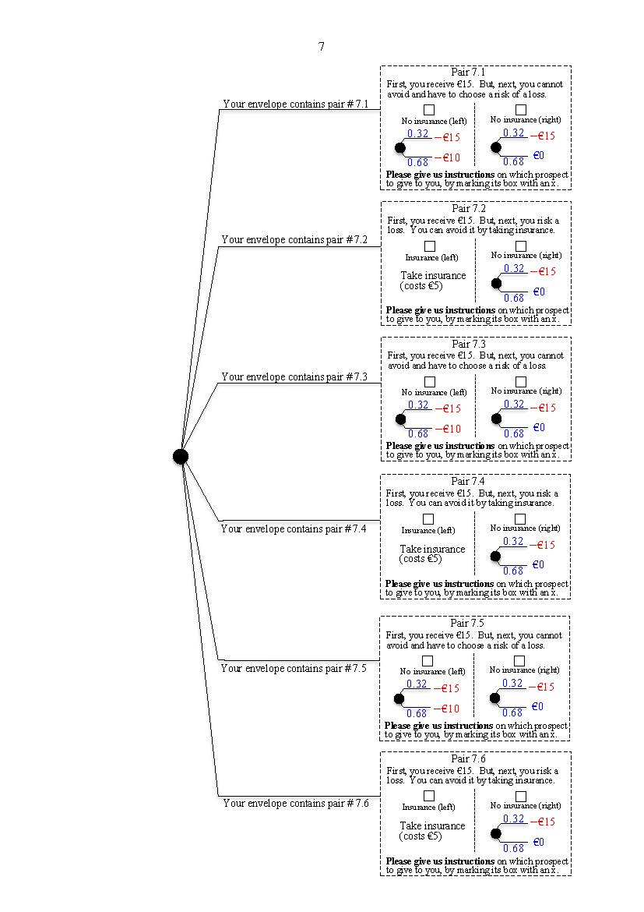

Page 7

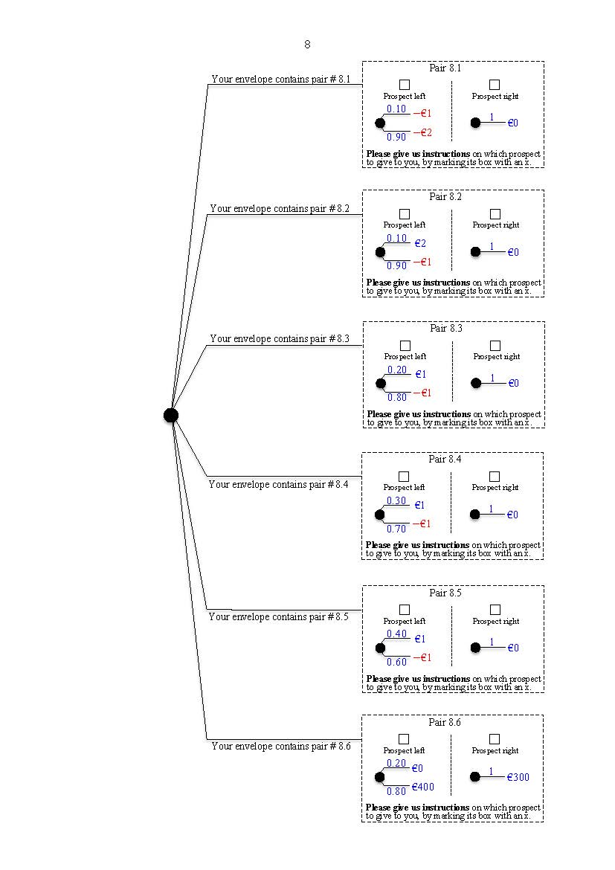

Page 8

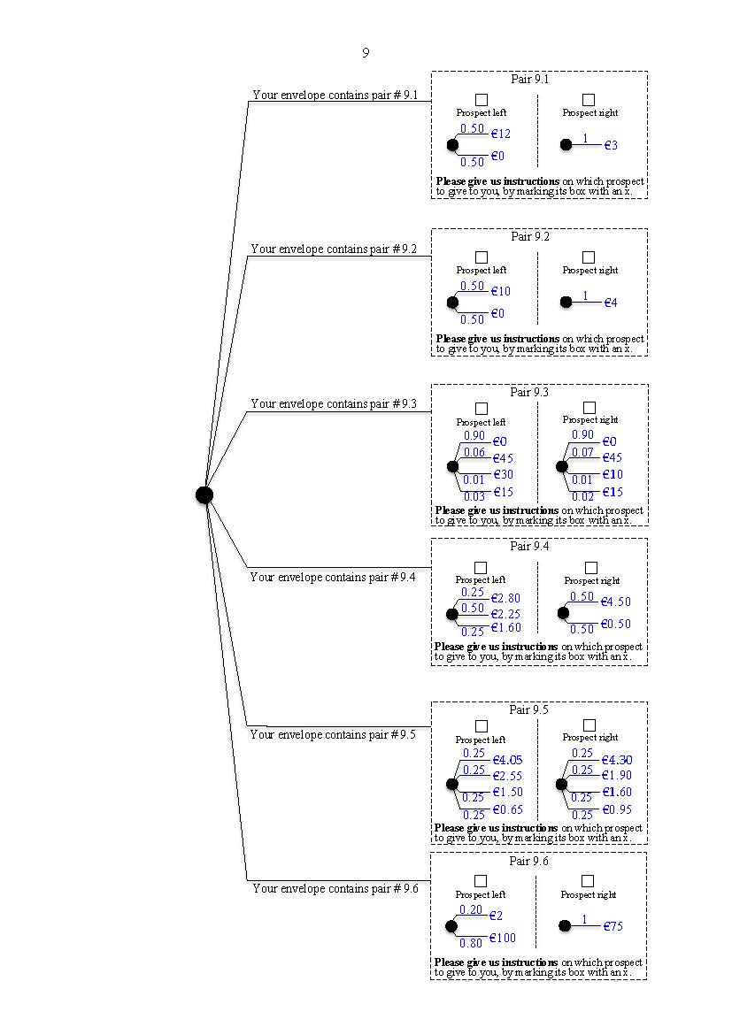

Page 9

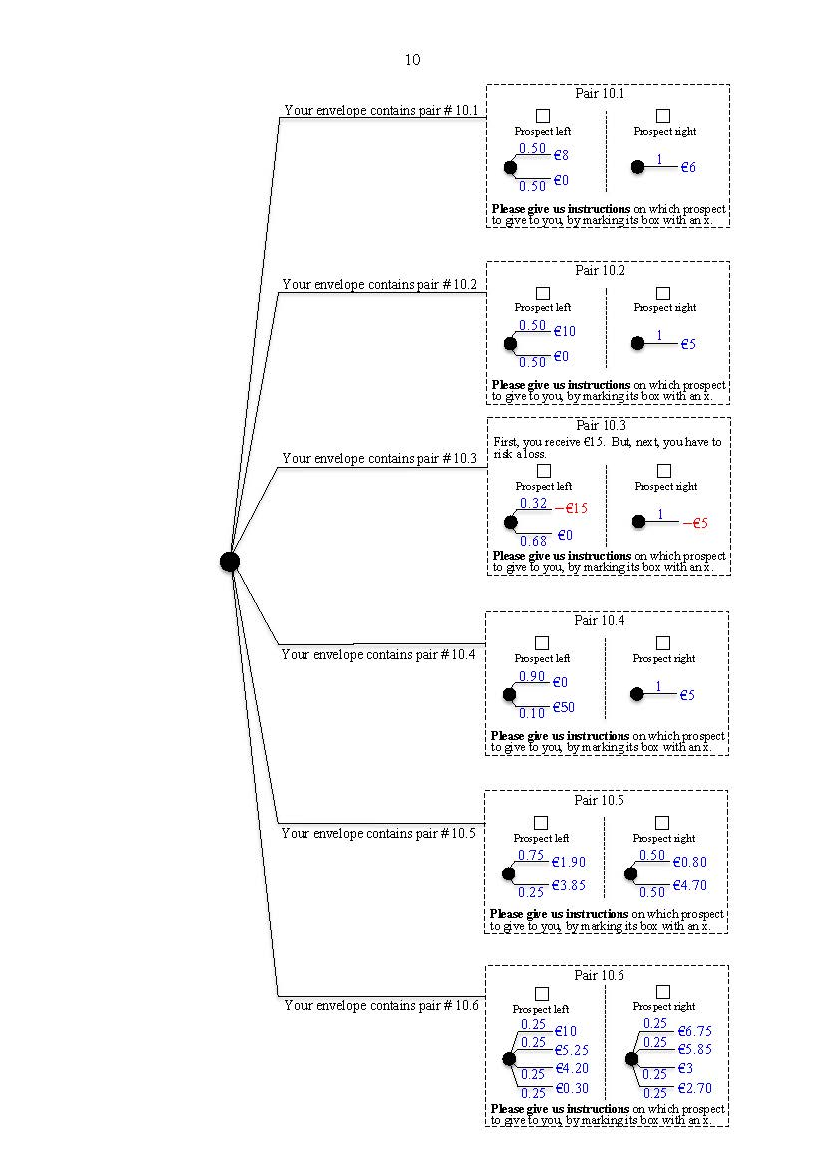

Page 10

The 10 pages follow next, nonreduced.

Pair 1.1

Prospect right

Prospect left

Your envelope contains pair # 1.1

1

0.85

$-$ €1

€0

0.15

$-$ €2

**Please give us instructions** on which prospect to give to you, by marking its box with an x.

Pair 1.2

Prospect right

Prospect left

Your envelope contains pair # 1.2

€2

0.10

1

€0

$-$ €1

0.90

**Please give us instructions** on which prospect to give to you, by marking its box with an x.

Pair 1.3

Prospect right

Prospect left

Your envelope contains pair # 1.3

0.20

€1

€0

1

$-$ €1

0.80

**Please give us instructions** on which prospect to give to you, by marking its box with an x.

Page 1

Pair 1.4

Prospect right

Prospect left

0.30

Your envelope contains pair # 1.4

€0

1

€1

$-$ €1

0.70

**Please give us instructions** on which prospect to give to you, by marking its box with an x.

Pair 1.5

Prospect right

Prospect left

Your envelope contains pair # 1.5

0.40

€0

1

€1

$-$ €1

0.60

**Please give us instructions** on which prospect to give to you, by marking its box with an x.

Pair 1.6

Prospect right

Prospect left

Your envelope contains pair # 1.6

€5

1

0.90

€0

0.10

€50

**Please give us instructions** on which prospect to give to you, by marking its box with an x.

Your envelope contains pair # 2.1

Pair 2.1

Prospect right

Prospect left

1

€4

0.50

€10

€0

0.50

**Please give us instructions** on which prospect to give to you, by marking its box with an x.

Your envelope contains pair # 2.2

Pair 2.2

Prospect right

Prospect left

€0

€0

0.90

0.90

€45

€45

0.07

0.06

€10

€30

€15

0.01

€15

0.01

0.02

0.03

**Please give us instructions** on which prospect to give to you, by marking its box with an x.

Pair 2.3

Your envelope contains pair # 2.3

Prospect left

Prospect right

0.20

€10

1

€0

0.75

0.05

€7

€7

Page 2

**Please give us instructions** on which prospect to give to you, by marking its box with an x.

€5

€0

Pair 2.4

Prospect right

0.20

€3

Prospect left

0.25

€0

0.80

0.75

**Please give us instructions** on which prospect to give to you, by marking its box with an x.

Your envelope contains pair # 2.4

Pair 2.5

Prospect right

Prospect left

Your envelope contains pair # 2.5

0.50

€10

€5

1

€0

0.50

**Please give us instructions** on which prospect to give to you, by marking its box with an x.

1

€45

Pair 2.6

Prospect right

Prospect left

0.10

€0

€50

0.90

**Please give us instructions** on which prospect to give to you, by marking its box with an x.

Your envelope contains pair # 2.6

**Please give us instructions** on which prospect to give to you, by marking its box with an x.

Prospect left

Page 3

Your envelope contains pair # 3.1

Your envelope contains pair # 3.2

Your envelope contains pair # 3.3

Your envelope contains pair # 3.5

Your envelope contains pair # 3.4

Your envelope contains pair # 3.6

0.25

€0.80

€4.70

Pair 3.2

Prospect right

0.50

€1.90

Prospect left

0.75

€3.85

0.50

0.25

**Please give us instructions** on which prospect to give to you, by marking its box with an x.

Prospect left

€2.80

€2.25

Prospect left

€2.80

€2.25

€1.60

€0.80

€4.70

Pair 3.3

Prospect right

0.50

€1.90

Prospect left

0.75

€3.85

0.50

0.25

**Please give us instructions** on which prospect to give to you, by marking its box with an x.

€4.50

€0.50

Prospect right

0.50

0.50

Pair 3.5

0.25

0.50

0.25

€2.80

€2.25

€1.60

**Please give us instructions** on which prospect to give to you, by marking its box with an x.

€4.50

€0.50

Prospect right

0.50

0.50

Pair 3.6

0.50

0.25

€1.60

Pair 3.4

€4.50

€0.50

Prospect right

0.50

0.50

0.25

0.50

0.25

**Please give us instructions** on which prospect to give to you, by marking its box with an x.

€0.80

€4.70

Pair 3.1

Prospect right

0.50

€1.90

Prospect left

0.75

€3.85

0.50

0.25

**Please give us instructions** on which prospect to give to you, by marking its box with an x.

*Below, questions will be repeated. That is, you will see the same pair three times, one after the other.*

*Below, questions will be repeated. That is, you will see the same pair three times, one after the other.*

0.25

0.25

0.25

0.25

€2.55

€4.05

Your envelope contains pair # 4.6

Prospect left

Prospect right

0.25

0.25

0.25

0.25

0.25

0.25

€2.55

€4.05

Your envelope contains pair # 4.5

Prospect left

Prospect right

**Please give us instructions** on which prospect to give to you, by marking its box with an x.

0.25

0.25

0.25

0.25

0.25

0.25

0.25

€1.60

€1.50

€1.50

€1.50

€0.95

€0.65

€0.65

€0.65

0.25

0.25

€2.55

€4.05

€4.30

€1.90

€1.90

€1.90

Your envelope contains pair # 4.4

0.25

Prospect left

Prospect right

**Please give us instructions** on which prospect to give to you, by marking its box with an x.

0.25

Page 4

0.25

0.25

€5.25

0.25

0.25

€10

Your envelope contains pair # 4.3

Prospect left

**Please give us instructions** on which prospect to give to you, by marking its box with an x.

0.25

€3

€4.20

€3

€4.20

€2.70

€0.30

€0.30

0.25

0.25

€5.25

0.25

0.25

€10

Your envelope contains pair # 4.2

Prospect left

0.25

0.25

0.25

0.25

0.25

0.25

0.25

0.25

€2.70

0.25

0.25

€5.25

€3

€4.20

0.25

0.25

€10

Prospect left

Prospect right

Pair 4.1

Your envelope contains pair # 4.1

€6.75

€5.85

€0.30

**Please give us instructions** on which prospect to give to you, by marking its box with an x.

Pair 4.2

Prospect right

€6.75

€5.85

0.25

Pair 4.3

Prospect right

€6.75

€5.85

€2.70

0.25

Pair 4.4

0.25

0.25

Pair 4.5

€4.30

€1.60

€0.95

**Please give us instructions** on which prospect to give to you, by marking its box with an x.

Pair 4.6

€4.30

€0.95

0.25

0.25

**Please give us instructions** on which prospect to give to you, by marking its box with an x.

€1.60

Your envelope contains pair # 5.1

€7

€0

Pair 5.1

Prospect right

0.25

€10

Prospect left

0.20

€0

0.75

0.80

**Please give us instructions** on which prospect to give to you, by marking its box with an x.

*Below, questions will be repeated. That is, you will see the same pair three times, one after the other.*

€7

€0

Pair 5.2

Prospect right

0.25

€10

Prospect left

0.20

€0

0.75

0.80

**Please give us instructions** on which prospect to give to you, by marking its box with an x.

Your envelope contains pair # 5.2

€7

€0

Pair 5.3

Prospect right

0.25

€10

Prospect left

0.20

€0

0.75

0.80

**Please give us instructions** on which prospect to give to you, by marking its box with an x.

Your envelope contains pair # 5.3

Page 5

Pair 5.4

Prospect right

Your envelope contains pair # 5.4

0.20

Prospect left

€10

€7

0.75

€0

€7

1

0.05

**Please give us instructions** on which prospect to give to you, by marking its box with an x.

Pair 5.5

Prospect right

0.20

Your envelope contains pair # 5.5

Prospect left

€7

0.75

€7

€10

1

0.05

€0

**Please give us instructions** on which prospect to give to you, by marking its box with an x.

Pair 5.6

Prospect right

Your envelope contains pair # 5.6

0.20

Prospect left

€10

0.75

€7

1

€7

0.05

€0

**Please give us instructions** on which prospect to give to you, by marking its box with an x.

Your envelope contains pair # 6.1

€5

€0

Pair 6.1

Prospect right

0.20

€3

Prospect left

0.25

€0

0.80

0.75

**Please give us instructions** on which prospect to give to you, by marking its box with an x.

1

€6

Pair 6.2

Prospect right

Prospect left

0.80

€10

€0

0.20

**Please give us instructions** on which prospect to give to you, by marking its box with an x.

Your envelope contains pair # 6.2

€10

€0

Pair 6.3

Prospect right

0.20

€6

Prospect left

0.25

€0

0.80

0.75

**Please give us instructions** on which prospect to give to you, by marking its box with an x.

Your envelope contains pair # 6.3

Page 6

Prospect right

Pair 6.4

Prospect left

Your envelope contains pair # 6.4

0.75

0.05

0.75

0.20

€12

€12

€10

€6

0.25

€0

**Please give us instructions** on which prospect to give to you, by marking its box with an x.

Pair 6.5

Prospect right

Prospect left

Your envelope contains pair # 6.5

1

0.80

€22

€18

€12

0.20

**Please give us instructions** on which prospect to give to you, by marking its box with an x.

€7

€0

Pair 6.6

Prospect right

0.25

€10

Prospect left

0.20

€0

0.75

0.80

**Please give us instructions** on which prospect to give to you, by marking its box with an x.

Your envelope contains pair # 6.6

Pair 7.1

First, you receive €15. But, next, you cannot avoid and have to choose a risk of a loss.

Your envelope contains pair # 7.1

No insurance (left)

No insurance (right)

0.32

$-$ €15

$-$ €15

0.32

$-$ €15

$-$ €10

0.68

€0

0.68

**Please give us instructions** on which prospect to give to you, by marking its box with an x.

Pair 7.2

First, you receive €15. But, next, you risk a loss. You can avoid it by taking insurance.

Insurance (left)

Take insurance (costs €5)

No insurance (right)

Your envelope contains pair # 7.2

0.32

€0

0.68

**Please give us instructions** on which prospect to give to you, by marking its box with an x.

Pair 7.3

First, you receive €15. But, next, you cannot avoid and have to choose a risk of a loss.

No insurance (left)

No insurance (right)

Your envelope contains pair # 7.3

$-$ €15

0.32

0.32

$-$ €15

$-$ €10

0.68

€0

0.68

**Please give us instructions** on which prospect to give to you, by marking its box with an x.

Page 7

Pair 7.4

First, you receive €15. But, next, you risk a loss. You can avoid it by taking insurance.

Insurance (left)

Take insurance (costs €5)

No insurance (right)

0.32

Your envelope contains pair # 7.4

$-$ €15

$-$ €15

€0

0.68

**Please give us instructions** on which prospect to give to you, by marking its box with an x.

Pair 7.5

First, you receive €15. But, next, you cannot avoid and have to choose a risk of a loss.

No insurance (left)

No insurance (right)

Your envelope contains pair # 7.5

$-$ €15

0.32

0.32

$-$ €15

$-$ €10

0.68

0.68

€0

**Please give us instructions** on which prospect to give to you, by marking its box with an x.

Pair 7.6

First, you receive €15. But, next, you risk a loss. You can avoid it by taking insurance.

Insurance (left)

Take insurance (costs €5)

No insurance (right)

Your envelope contains pair # 7.6

0.32

**Please give us instructions** on which prospect to give to you, by marking its box with an x.

0.68

€0

Your envelope contains pair # 8.1

1

€0

Pair 8.1

Prospect right

Prospect left

0.10

$-$ €1

$-$ €2

0.90

**Please give us instructions** on which prospect to give to you, by marking its box with an x.

1

€0

Pair 8.2

Prospect right

Prospect left

0.10

€2

$-$ €1

0.90

**Please give us instructions** on which prospect to give to you, by marking its box with an x.

Your envelope contains pair # 8.2

1

€0

Pair 8.3

Prospect right

Prospect left

0.20

€1

$-$ €1

0.80

**Please give us instructions** on which prospect to give to you, by marking its box with an x.

Your envelope contains pair # 8.3

Page 8

1

€0

Pair 8.4

Prospect right

Prospect left

0.30

€1

$-$ €1

0.70

**Please give us instructions** on which prospect to give to you, by marking its box with an x.

Your envelope contains pair # 8.4

1

€0

Pair 8.5

Prospect right

Prospect left

0.40

€1

$-$ €1

0.60

**Please give us instructions** on which prospect to give to you, by marking its box with an x.

Your envelope contains pair # 8.5

1

€300

Pair 8.6

Prospect right

Prospect left

0.20

€0

€400

0.80

**Please give us instructions** on which prospect to give to you, by marking its box with an x.

Your envelope contains pair # 8.6

Your envelope contains pair # 9.1

Prospect right

Pair 9.1

Prospect left

0.50

€12

1

€3

€0

0.50

**Please give us instructions** on which prospect to give to you, by marking its box with an x.

Pair 9.2

Prospect right

Prospect left

Your envelope contains pair # 9.2

1

€4

0.50

€10

0.50

€0

**Please give us instructions** on which prospect to give to you, by marking its box with an x.

Pair 9.3

Prospect right

Prospect left

Your envelope contains pair # 9.3

0.90

0.90

€45

€0

€0

€45

0.07

0.06

0.01

0.01

€30

€10

Page 9

€15

€15

0.02

0.03

**Please give us instructions** on which prospect to give to you, by marking its box with an x.

€4.50

€0.50

Prospect right

0.50

0.50

Pair 9.4

Prospect left

Your envelope contains pair # 9.4

0.50

0.25

€2.80

€2.25

Pair 7.5

€15

0.01

€0

0.03

€45

0.06

€30

0.90

O``ion right

O``ion left

€15

0.01

€0

0.02

€45

0.07

€10

0.90

**Please give us instructions** on which o``on to give to you, by marking its box with an x.

0.25

€1.60

**Please give us instructions** on which prospect to give to you, by marking its box with an x.

Pair 9.5

Prospect right

Prospect left

Your envelope contains pair # 9.5

€4.30

€4.05

0.25

0.25

€1.90

€1.50

€1.60

€2.55

0.25

0.25

€0.65

€0.95

0.25

0.25

0.25

0.25

**Please give us instructions** on which prospect to give to you, by marking its box with an x.

Pair 9.6

Prospect right

Prospect left

Your envelope contains pair # 9.6

1

0.20

€2

€75

€100

0.80

**Please give us instructions** on which prospect to give to you, by marking its box with an x.

Your envelope contains pair # 10.1

Pair 10.1

Prospect right

Prospect left

0.50

1

€6

€8

€0

0.50

**Please give us instructions** on which prospect to give to you, by marking its box with an x.

Pair 10.2

Prospect right

Prospect left

Your envelope contains pair # 10.2

1

€5

0.50

€10

€0

0.50

**Please give us instructions** on which prospect to give to you, by marking its box with an x.

Pair 10.3

First, you receive €15. But, next, you have to risk a loss.

Your envelope contains pair # 10.3

Prospect right

Prospect left

1

$-$ €5

0.32

$-$ €15

0.68

€0

**Please give us instructions** on which prospect to give to you, by marking its box with an x.

Page 10

Pair 10.4

Prospect right

Prospect left

Your envelope contains pair # 10.4

1

€5

0.90

€0

€50

0.10

**Please give us instructions** on which prospect to give to you, by marking its box with an x.

0.50

0.50

€0.80

€4.70

Pair 10.5

Prospect right

€1.90

Prospect left

0.75

€3.85

0.25

**Please give us instructions** on which prospect to give to you, by marking its box with an x.

Your envelope contains pair # 10.5

Pair 10.6

Prospect right

Prospect left

Your envelope contains pair # 10.6

€6.75

€4.20

€3

€10

0.25

0.25

€5.85

€5.25

0.25

0.25

**Please give us instructions** on which prospect to give to you, by marking its box with an x.

€0.30

€2.70

0.25

0.25

0.25

0.25